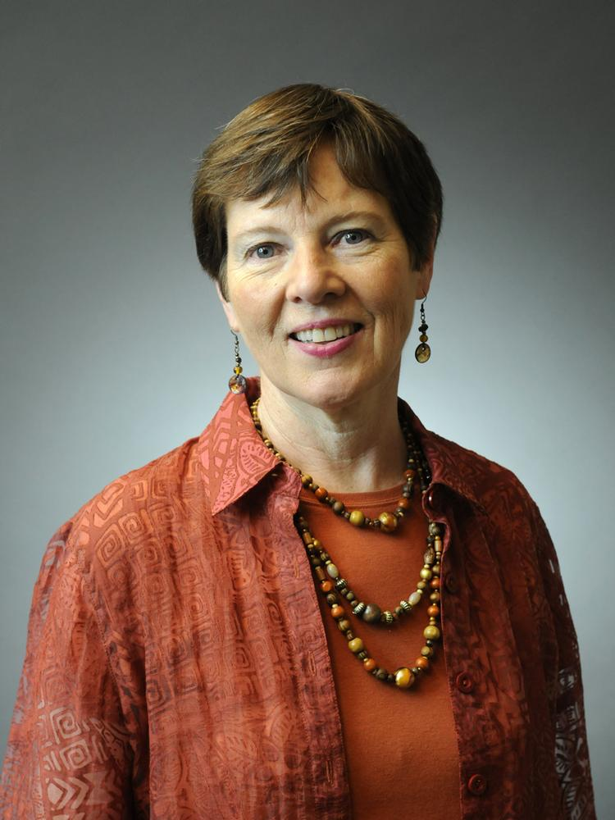
Mary Healy was Sacramento Zoo’s director for nearly 15 years. Mary served as a chair of the Association of Zoos and Aquariums. She also was president of the California Association of Zoos and Aquariums and was one of nine international council members of the World Association of Zoos and Aquariums.
Healy started her career in 1975 as a bird keeper and became the assistant bird curator at Riverbanks Park in Columbia, S.C. After serving as bird curator at the San Antonio Zoo for seven years, Healy spent nine years as director of Discovery Island Zoological Park at Walt Disney World in Orlando, Fla. Then served as Sacramento Zoo’s director for nearly 15 years. Mary served as a chair of the Association of Zoos and Aquariums. She also was president of the California Association of Zoos and Aquariums and was one of nine international council members of the World Association of Zoos and Aquariums.
Mary and a group of bird curators started the Avian Interest Group, the progenitor of the ASAG, long before there were official Taxon management groups in the AZA. Other Taxon groups saw and started their own management organizations. Eventually these were officially incorporated into the AZA to form TAGs, SSPs and other management tools.
Mary Healy is also the founder of the ASAG wine and cheese fundraising, holding the first event in her hotel room at the National AZA (nee AAZPA) conference.
Mary should not be forgotten since she was instrumental organizing bird taxons into a group that set the standard for how we manage birds (and other assorted life forms.) in the AZA today. She was a true bird person and always worked at promoting and highlighting the importance of bird collections in the AZA. Mary Healy spoke for the birds.

